./

A

Project Report

on

Selenium Automation :Starbucks Automation

Submitted as a partial fulfillment

of the module

Object-Oriented Programming using Python

Submitted To: Jaishree Tailor

Module Faculty (GENESIS Q3 FY 23)



Submitted By:

|  |  |  |  |
| --- | --- | --- | --- |
| **Mini-App Project Team Details** | | | |
| **PS.No.** | **Full Name** | **Email** | **BU** |
| 40032345 | Priya Birjuprasad Kanojiya | Priya.Kanojiya@ltts.com | EMB-TET |











# Selenium Automation

* **Selenium is a free (open-source) automated testing framework used to validate web applications across different browsers and platforms.**
* **The code gives user to access the website of Starbucks and options to select operations which is to be performed.**
* **It’s a menu driven program.**
* **There are options to select an item and another option for exception.**

# App Implementation Source File Structure and Individual Contribution

This section must have 2 items:

### Screenshot of the PyCharm Project with its File Structure. It must have the File Explorer View for all the source files, modules created.

### File Summary

|  |  |  |  |
| --- | --- | --- | --- |
| Items | Items | Description | Responsible Member PSNO. |
| Modules | Web Driver | Used for to Automate web elements. | 40032345 |
| Time | To give implicit wait and sleep time. | 40032345 |
|  |  |  |
| Packages | Selenium | To do web automation using web. | 40032345 |
|  |  |  |
| Source files | oops.py | Main automation file. | 40032345 |
| pytest.py | File for pytest |  |



# gitGEA Dashboard

This section must have 2 items:

### gitGEA Link of each member

|  |  |
| --- | --- |
| PSNO | gitGEA Link |
| 40032345 | https://github.com/PriyaKanojiya/OOPS-Project.git |

### gitGEA Dashboard view of each member

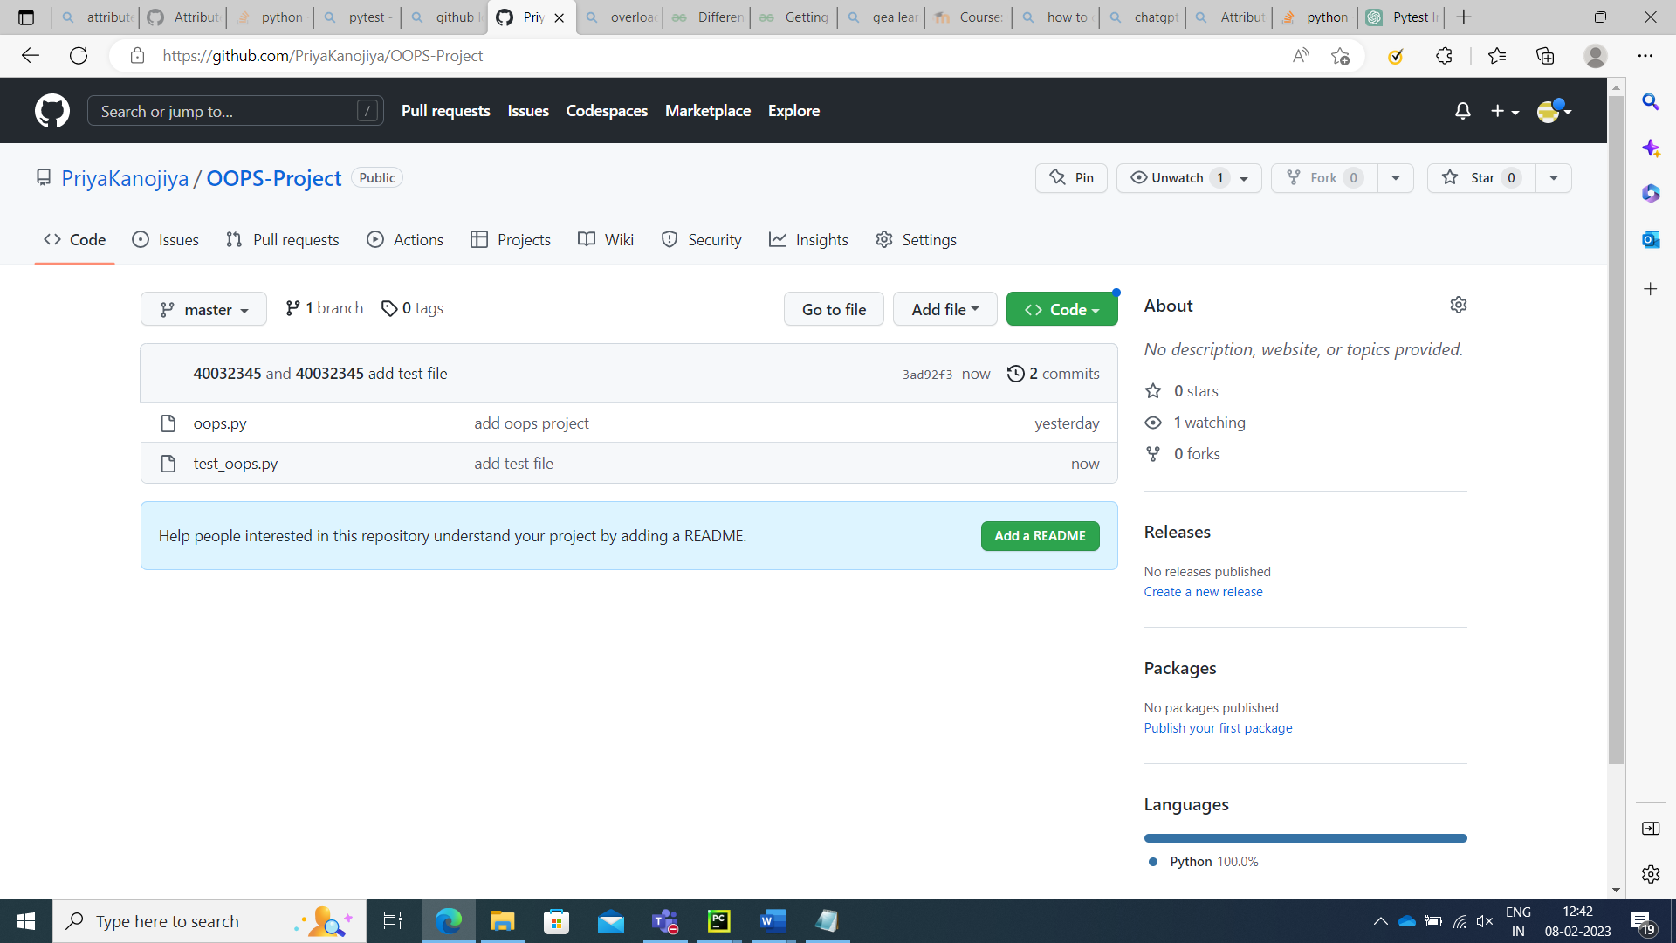

Figure 1

# OOP Concept Utilization Summary

This section must have following items:

|  |  |
| --- | --- |
| Concept | Description |
| Class | Starbucks : To initialize and navigate website. StarbucksMenu : It is a class which handle exceptions and throw error. |
| Objects | s : This object is for access class and its methods. |
| Instance Methods | navigate_to_starbucks :This method launches the or open the website. click_menu : This method is used to click on element to select menu. |
| Inheritance | Type of Inheritance : Single inheritance |
| Base Classes : StarbucksChild Classes : StarbucksMenu |
| Exception Handling | List Exception Types : User defined exception. |
| Overriding | Click menu is override in the classes. |







# App Implementation Console Layouts

This section must have 2 items:

### Screenshot of each menu option implemented based on the requirement along with the output.

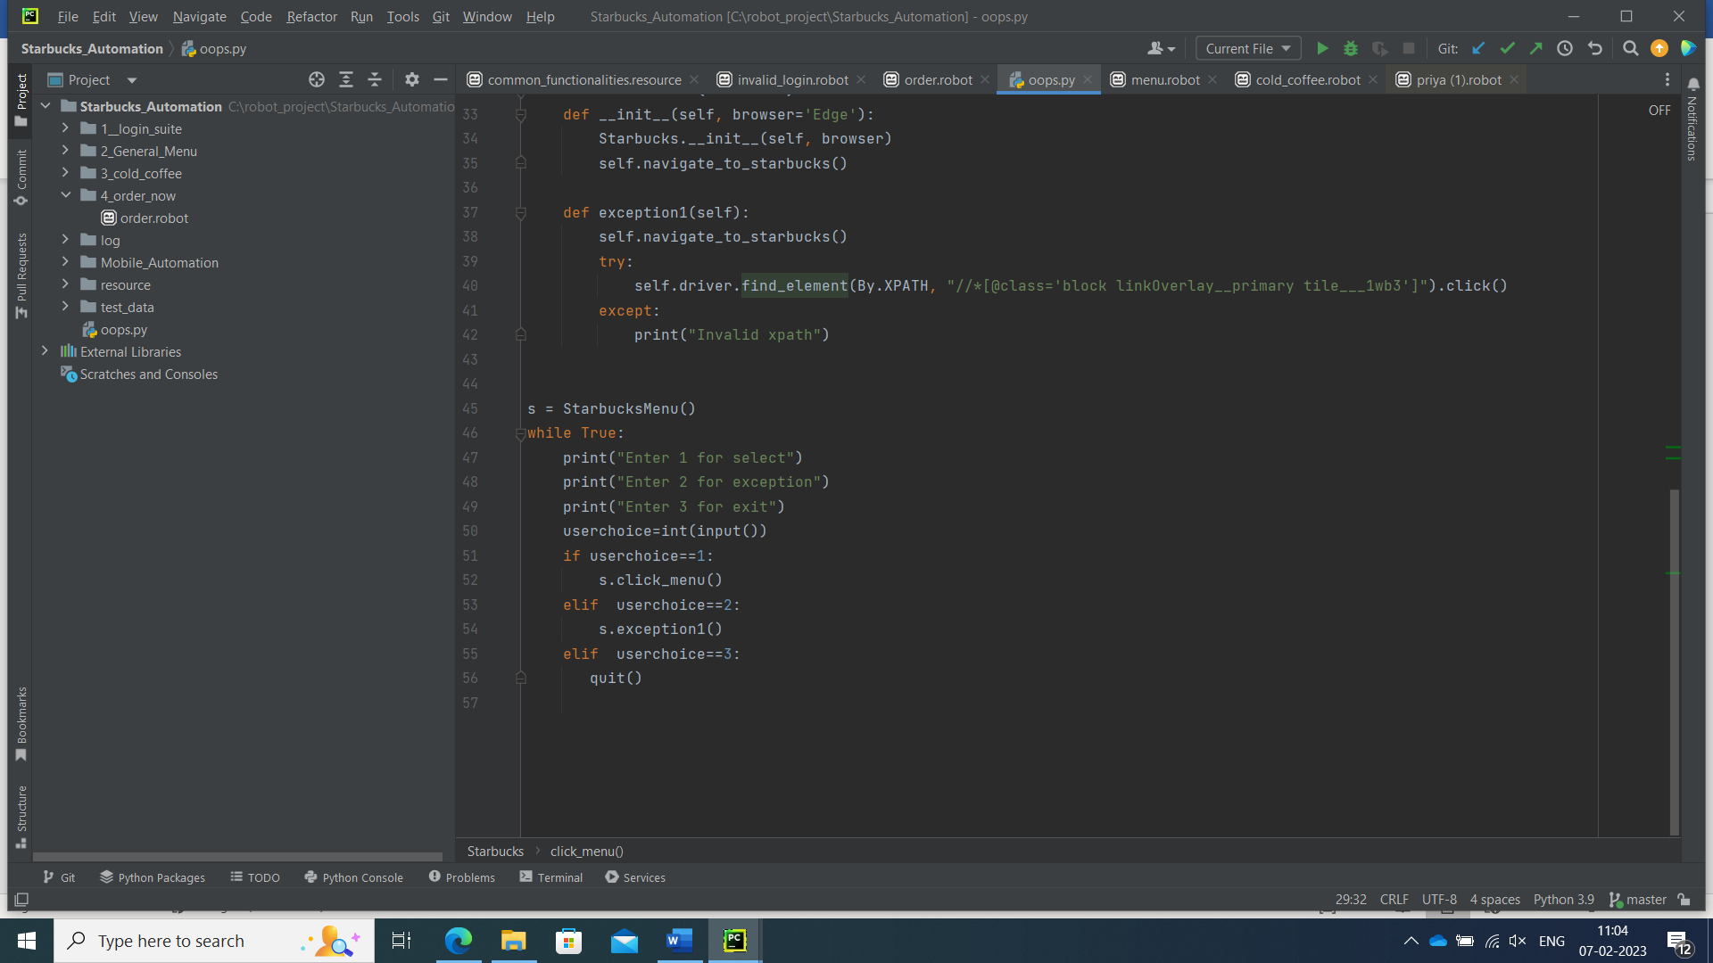

Figure 2 Screenshot of <<menu option>>

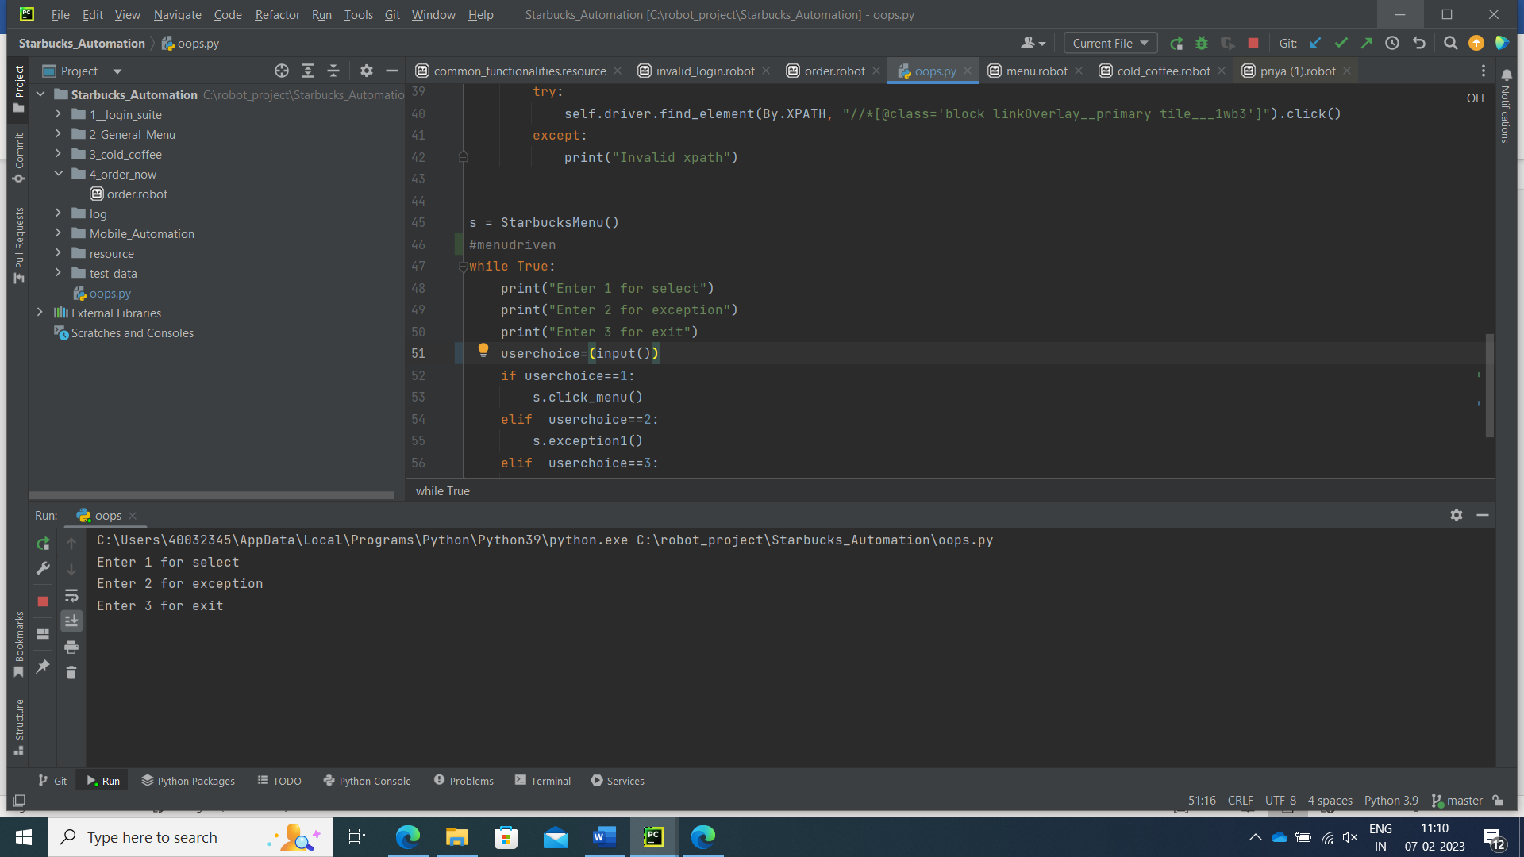

Figure 3 Screenshot of <<menu option>>

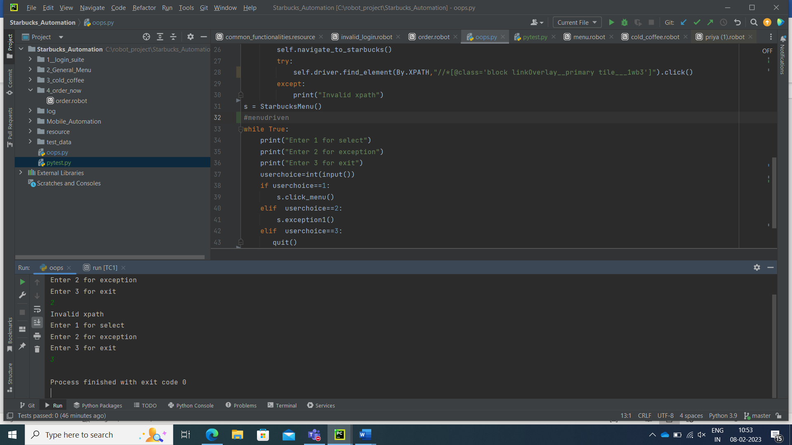

Figure 4

### Brief description of the code, it’s input and output

* The code gives user to access the website of Starbucks and options to select operations which is to be performed.
* There are options to select an item and another option for exception.
* In this we used single type of inheritance.
* There are two classes with inheritance which include all the methods.
* In this all the methods are instances.
* Navigate to website is instance method which perform respective tasks like to the given URL and give user to access website.
* To Inspect, various keywords are used like , find elements by XPATH and click elements by XPATH.



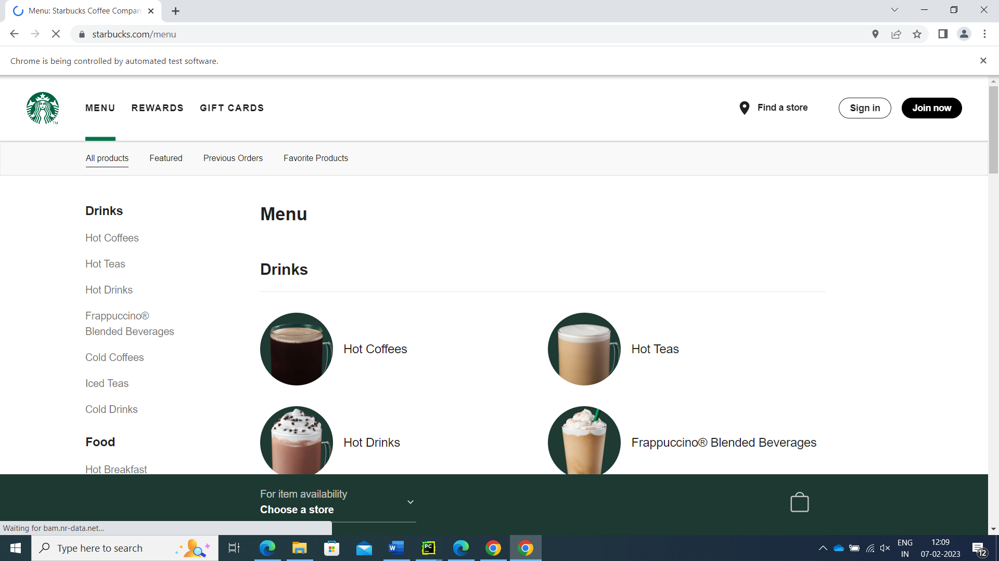

Figure 5

TESTING

### This section must have 2 items:

### Screenshot test files along with test methods demonstrating fixtures, parametrization, marking, xfail, xskip

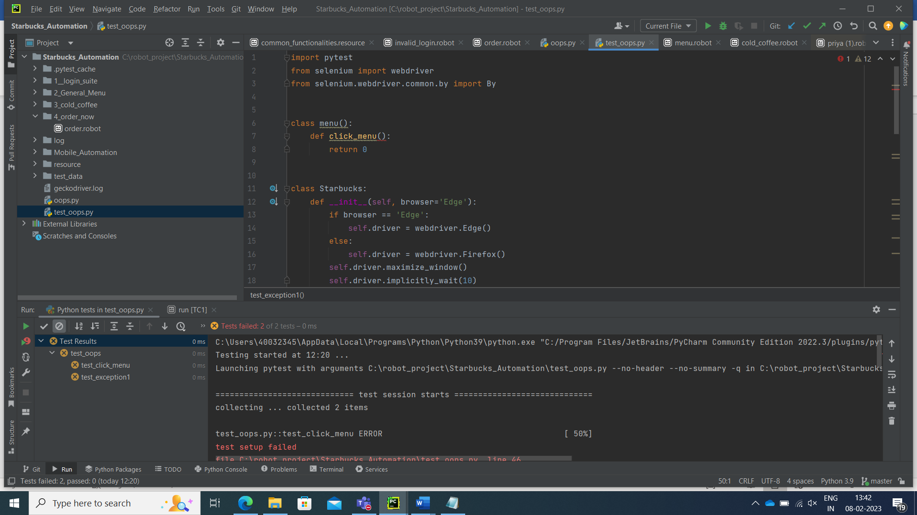

Figure 6 Screenshot of pytest



Figure 7 Screenshot of pytest

# Standard Coding Practice Summary

This section PyLint report for any one source file per member. Fix the code with standard practice and re-run for PyLint report

|  |  |  |  |
| --- | --- | --- | --- |
| PSNO | Source File Name | Quality Index and Suggestions before PyLint Recommendation | Quality Index and Suggestions after PyLint Recommendation |
| 40032345 | Oops.py | 6.00 | 6.67 |

# 

# Learnings from the Mini-Ap p Project Journey

* In this project we tried to apply the concepts of oops in selenium automation project.
* Classes ,Object , exception handling and pytest are implemented.
* The code gives user to access the website of Starbucks and options to select operations which is to be performed.
* It’s a menu driven program.
* There are options to select an item and another option for exception.
* Understanding of the inheritance concept in OOP.
* Usage of Selenium WebDriver to automate web applications.
* Locating web elements using different strategies like By.LINK_TEXT, By.NAME, By.CLASS_NAME, By.ID,   and By.XPATH.
* Exception handling in Python.
* Implementing a user interface for user interaction.
* Testing for functions is done using pytest.

# References

1. [Selenium Python Tutorial with WebDriver Example (guru99.com)](https://www.guru99.com/selenium-python.html)
2. [Python Inheritance (w3schools.com)](https://www.w3schools.com/python/python_inheritance.asp" \l ":~:text=Inheritance%20allows%20us%20to%20define,class%2C%20also%20called%20derived%20class)
3. [python - How to run Pylint with PyCharm - Stack Overflow](https://stackoverflow.com/questions/38134086/how-to-run-pylint-with-pycharm)
4. [pytest-dev/pytest-selenium: Plugin for running Selenium with pytest (github.com)](https://github.com/pytest-dev/pytest-selenium)
5. [python_selenium_concepts_tata_tech/demo1_basics at master · balaji-githubstore/python_selenium_concepts_tata_tech](https://github.com/balaji-githubstore/python_selenium_concepts_tata_tech/tree/master/demo1_basics)